YEAR 10 SCIENCE (ADJUSTED)
PHYSICAL SCIENCES
REVISION - TEST 2

1. A dragster at Kwinana Motorplex uniformly accelerates from rest and covers the 400 m track in 7.101 s with a final speed of 85.8 m/s. Calculate the acceleration of the vehicle.
(Use )

2. The highest "ridiculous" basketball shot is currently 201.4 m from the top of Maletsuyane Falls in Lesotho. Assuming the initial vertical velocity is zero when it is released and it takes 6.41 s to fall, how fast was the ball moving vertically when it reached the ring? The acceleration due to gravity is 9.80 m/s². (Use v = u + at)

3. An ES-3A Shadow jet moving at 66.7 m/s relative to an aircraft carrier lands on its flight deck and the tail hook snags the arresting wire, which stops the jet in 2.30 s. Determine the deceleration experienced by the pilot. (Use )

4. Complete these statements about Newton’s three laws of motion.

(a) An object remains at rest, or will not change its speed or direction, unless ...

(b) When an unbalanced force acts on an object, the mass of an object affects ...

(c) For every action, there is ...

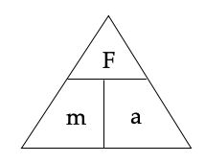

5. Complete the following table.

Force | Mass | Acceleration
100 N |  | 5 m/s²
 | 0.300 kg | 4 m/s²
1.2 N | 2 kg

6. Explain why the following statement is false:
A car travelling along a straight road has no forces acting on it.

7. Explain in terms of Newton’s First Law of Motion and inertia why it is dangerous to have loose objects inside a moving car.


8. Use Newton’s Second Law to calculate answers for the following.

(a) A 1400 kg car accelerates at 3.0 m/s². What size force is needed to cause this acceleration?

(b) A force of 160 N causes an object to accelerate at 2.0 m/s². What is the object’s mass?

(c) A force of 210 N acts on a mass of 70 kg. What is the acceleration?

9. (a) Explain the difference between mass and weight. Give an example to help your explanation.

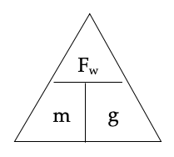
(b) The acceleration due to gravity on Jupiter is 22.5 m/s². Calculate the weight of a 450 kg object on Jupiter.

10. Consider the forces acting on a body of mass 40 kg resting on a frictionless surface.

(a) Calculate the net force acting on the body.

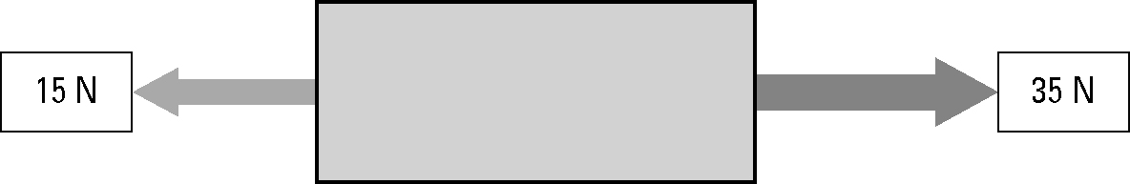



(b) Calculate the acceleration of the body.

11. What is the difference between a primary safety feature and a secondary safety feature?

12. By increasing the time over which a collision occurs, the force of the impact on a car and its passengers can be decreased.

List and describe at least two safety features of a car that decrease the force of impact in this way.

